3GPP TSG RAN WG1 Meeting #125 R1-2604381
Dalian, China, May. 18th ~ 22nd , 2026

Title: Overall views on 6G ISAC
Source: ZTE Corporation, Beijing Digital Nebula, Sanechips
Agenda item: 10.8.2
Document for: Discussion and decision

Introduction
In RAN#108，the 6G SID “New SID: Study on 6G Radio” was approved, regarding sensing are one of the key objectives as follows[1].
- Sensing – Studies to be based on use cases and associated requirements, as defined in [TR38.914]
- PHY functions and procedures for sensing technology (e.g., waveform. reference signals, measurement feedback, etc…) [RAN1, RAN4]
- Evaluate sensing performance and if necessary, extend channel modelling, for the selected use cases [RAN1]
- Aspects of integration with communication services [RAN1]
In this contribution, we mainly focus on detailed of aspect on integrating sensing and communication, e.g. design of reference signal, measurement report, sensing assisted communication, and so on. Firstly, we would summarize the main effort in 5G-A sensing and then provide proposals on 6G sensing.

Architecture and procedure

2.1. RAN architecture
From ZTE perspective, RAN architecture should consider followings aspects:
- From UE side, transferring all raw sensing data to SF would be unrealistic due to that the extremely large data size of sensing raw data would cause too much overhead on communication. Requiring UE to processing sensing measurement data to derive position and velocity of sensing target would also making too much burden on UE capability.
- Real time processing on sensing data collected from aNB and UE(s) on aNB would enable fast response on communication service according to related sensing measurement data, which is the principle of sensing assisted communication.
Considering that the size of raw data would be too delivered from UE to SF, and report of point cloud or trajectory point would call for too much processing capability on UE, the reasonable solution is that aNB collects and pre-processes UE measurement data and then deliver to SF. What’s more, sensing RS configuration would also be more accurate and fast for aNB to configure to UE because of the sensing measurement data on aNB. Such solution could has following advantages:
- More flexibility, and easy deployed for a necessarily dedicated area.
- Low latency of sensing measurement, report and computation
- Efficient for sensing assisting communication or communication assisting sensing
- Suitable for BS mono-static and BS bi-static.
Figure 2.1-1 RAN architecture of sensing

Proposal 1: From RAN1 perspective, study the procedure/signaling among aNB, UE, and SF.

2.2. Sensing modes
Basically, the sensing schemes can be grouped into the following 6 sensing modes. Mode A, which is TRP mono-static mode, has been studied since 5G-A, the single TRP transmits sensing signal and also receives the reflected signal through the sensing target, showing advantages on accuracy and implementation. In the mode B, i.e. TRP bi-static mode where TRP A transmits sensing signal and TRP B receives the reflected signal. In the mode C, it is the same as the current 5G DL measurement where TRP transmits sensing signal and UE receives the reflected signal. In the mode D, it is the same as the current 5G UL measurement where UE transmits sensing signal and TRP receives the reflected signal. In the mode E and F, they are similar as mode A and mode B respectively where TRP is replaced by UE. For sensing mode F, i.e. bi-static sensing modes, the discussion related to sidelink may be needed. However, the sidelink sensing may rely on the basic design for communication, such as sidelink DCI, SCI design similar as NR, we suggest prioritizing other sensing modes without sidelink involvement in Rel-20.

Figure 2.2-1 Sensing modes
The differences of 6 modes can be categorized into the following two aspects: the node type, and the sensing mode. Both two types greatly affect the sensing performance. For the sensing node. The sensing TX or RX node can be a TRP or a UE, which obviously leads to a huge difference. The node type further leads to the following differences.
- Hardware. The hardware of TRP is much better than that of UE, and TRP can provide higher transmitting power, better receiving sensitivity and large antenna array, which are essential to the sensing performance.
- Height. The height is also very important for the sensing coverage. TRP is much higher than UE, and a much higher LOS probability can be achieved.
- Motion state. The TRP is motionless, while the UE is mobile. In UAV detection use case, it is important to assume the sensing TX and RX do not move. Otherwise, it will be very challenging to remove the static clutters, which have a much higher power than the echo power of UAV.
Whether it is mono-static or bi-static is also a crucial factor, which has the following impacts:
- Coverage. Compared with bi-static, mono-static has better sensing field of view (FoV), because the effective sensing FoV is the intersection of Tx FoV and Rx FoV. It is very difficult to use bi-static sensing to cover a large area, which also brings challenges in terms of the TRP deployment and UE selection.
- Phase synchronization. The TX node and RX node in mono-static sensing use one hardware, while those in bi-static sensing have separate hardware. As Doppler is calculated basing on the phase information of received signal, phase synchronization is required for the bi-static sensing.
- Beam overhead. As the target echo is very weak, it is important to use beam for sensing, especially for FR2. For mono-static sensing, TX and RX beams are pointing at the same direction, which means the beam scanning overhead is O(N). However, for bi-static sensing, TX and RX beams are independent, and the beam scanning overhead surges to O(N²).
Some simulations are also done to compared the LOS probability of difference sensing modes, as shown in Fig. 2.2-2. The scenario is AGV detection in InF-SH, with a TRP height of 8m and UE height of 1.5m. It can be seen that TRP mono-static sensing gains a LOS probability of 0.83@CDF=0.1, which means in 90% cases, TRP mono-static can achieve a LOS probability not less than 0.83. As a comparison, the LOS probability for TRP bi-static sensing is 0.62@CDF=0.1, while that for TRP-UE bi-static sensing is only 0.18@CDF=0.1. For this simulation, it shows that TRP-UE bi-static cannot work alone due to the insufficient sensing capability. In this case, TRP-UE bi-static sensing should not work stand-alone, and it should be a backup of TRP mono-static sensing. There is a risk for TRP-UE bi-satic sensing to satisfy the sensing requirements, and we propose to study a multi-static mode including simultaneous TRP mono-static and TRP-UE bi-static.
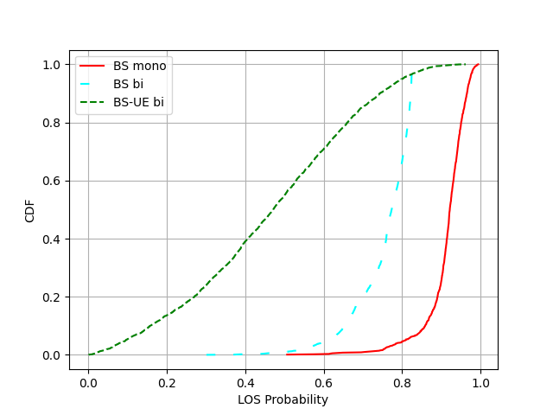
Fig. 2.2-2 CDF of Los probability in a InF-SH AGV detection scenario
Proposal 2: Study the following sensing modes without sidelink involvement for 6G ISAC.
- Mono-static: TRP mono-static, UE mono-static
- Multi-static: Simultaneous TRP mono-static and TRP-UE bi-static
- Bi-static: TRP bi-static, UE-TRP bi-static, TRP-UE bi-static, UE bi-static

2.3. Sensing procedures
Given the discussed RAN architecture and all sensing mode, we could list all types of potential interaction for all sensing mode.
Table 2.3-1 Potential Interactions between different entities for sensing modes from RAN1 perspective
 | TRP mono-static | TRP bi-static | TRP-UE bi-static | UE-TRP bi-static | UE mono-static | UE bi-static
SF-BS | √ | √ | √ | √ | √ | √
SF-UE | × | × | FFS | FFS | FFS | FFS
BS-UE | × | × | √ | √ | √ | √

Figure 2.3-1 Sensing interfaces among UE, BS and SF
Overall, based on the architecture and interface, we believe the whole sensing measurement procedure in physical layer could be divided into three steps shown as following figure:
Figure 2.3-2 Sensing signaling among UE, BS and SF
Step#1: Serving cell of the aNB configures sensing RS resource configuration to UE
Rather than SF, sensing RS resources configured by aNB could allow more flexible RS pattern and RS activation/deactivation scheme. For example, semi-persistent and aperiodic sensing RS for both DL and UL, similar as SRS configuration in NR positioning could be configured by aNB. If the sensing RS is configured by SF, such dynamic configurations would be unrealistic due to the large delay between SF and aNB/UE.
In some sensing scenarios, such as cooperative sensing, multi-static sensing mode or interference mitigation, RS resource configuration could include both serving cell and neighbor cell’s RS.
Step#2: Serving cell of the aNB configures sensing report configuration to UE
Similar as dynamic sensing RS resource configuration, configured by aNB could allow more flexible sensing measurement report such as semi-persistent and aperiodic measurement report. What’s more, in the sensing assisted communication use case, small delay for sensing measurement data transferring is needed, then timely UE’s measurement report via layer-1 measurement report would be necessary. Therefore, sensing report configuration from serving cell of aNB would be most important candidate.
Step#3: UE reports sensing measurement to serving cell
From UE side, transferring all raw sensing data to SF would be unrealistic due to that the extremely large data size of sensing raw data would cause too much overhead on communication. Requiring UE to processing sensing measurement data to derive position and velocity of sensing target would also making too much burden on UE capability. Then there would be one potential method to UE report sensing measurement data to aNB by layer-1 signaling, and aNB processes measurement data into position/velocity of sensing target and then reports to SF.
What’s more, sensing measurement report by layer-1 signaling could enable low latency on aNB side for sensing assisted communication. Then timely scheduling on communication (such as beam, transmitting power, etc.) could be possible.
In conclusion, at least UE’s measurement report shall be visible to RAN, and let RAN forward some necessary UE’s measurement to SF.
Proposal 3: From RAN 1 perspective, to support of BS mono-static, UE mono-static (without PC5 interface), BS bi-static, BS->UE, UE->BS sensing modes, at least the following procedures can be the starting points
- Between BS and SF
  - aNB information transmitted from aNB to SF
  - Measurement request from SF to aNB
  - Measurement report from aNB to SF
- Between aNB and UE
  - UE capability from UE to aNB
  - RS configuration or assistance information from aNB to UE
  - Measurement request from aNB to UE
  - Measurement report from UE to aNB
    - Including sensing assists communication.
- RS configured by SF and sensing report from UE to SF are not supported considering latency and flexibility.

2.3.1. Sensing measurement request
For better RS configuration and sensing measurement, some more assistance information from SF/BS could be provided with signaling of measurement request. From our perspective, at least following information could be provided:
- Sensing area/range
For sensing service, the client may only need sensing results in a particular area. For instance, only an area overhead a airport is the sensing area where a aNB need sensing detection of UAV intrusion. In such case, SF/BS can provide sensing measurement pre-information of sensing area or sensing targets in the measurement request such as
- A range of potential sensing distance
- A range of potential sensing angle
- A range of potential sensing Doppler
- A range of potential receiving power (RSRP)
- A area of potential position of sensing target

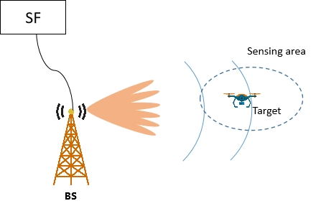
Figure 2.3.1-1 Sensing area information
- Features of potential sensing target/environmental clutter
In some sensing task, sensing device shall distinguish some detected object/sensing target from environmental clutter. Some assistance information helping sensing device to decide which measurement point/path is from sensing target and which is from environmental clutter could be provided by SF/BS in measurement request.
These information could be
- The potential information of sensing target, e.g. RCS, size, speed, type (e.g. UAV or car or human)
- The potential information of environmental clutter.
It is highly likely to reuse some communication RS for sensing usage, and such communication RS could be periodic, semi-persistent, or aperiodic RS. Such RS with dynamic characteristic and flexibility could only be configured by aNB. What’s more, even some dedicated sensing RS could also be used for communication, such as interference measurement. If such RS used for both communication and sensing is configured by SF, the large latency and only periodic RS would be harmful for communication service. Therefore, to allow flexible RS activation/deactivation, e.g., semi-persistent and aperiodic sensing RS for both DL and UL among all sensing modes, sensing RS should only be configured by aNB, not SF. Therefore, the sensing measurement request should be designed independently.
Proposal 4: From RAN1 perspective, the following can be studied as sensing measurement request from aNB to UE:
- Sensing mode
- Configurations of reference signal
- Requested measurement report metrics
- Sensing assistance data including
  - Sensing area such as Delay range, Doppler range, Angle range to be measured.
  - Characteristic of sensing targets
  - Any environmental clutter to be omitted.

Proposal 5: From RAN1 perspective, the following can be studied as sensing measurement request from SF to aNB:
- Sensing mode
- Requested measurement report metrics
- Sensing assistance data including
  - Sensing area such as Delay range, Doppler range, Angle range to be measured.
  - Characteristic of sensing targets
  - Any environmental clutter to be omitted.

2.3.2. Measurement report for sensing

2.3.2.1. Measurement report from RAN to SF
In 5G-A study, different levels and options of sensing measurement report from aNB to SF are studied, shown as following:
TR 38.765
From physical layer perspective, the following measurements that may be reported from RAN are identified in the study of NR ISAC.
- Level A: Raw data per Tx antenna port per OFDM symbol per RX antenna port per TRP for a given time stamp
- Option A1: Amplitude and phase samples in time/delay domain of the estimated channel, i.e., Amplitude and phase values of channel impulse response
- Option A2: Amplitude and phase per subcarrier in frequency domain of the estimated channel
- Level B: Amplitude and phase profile of delay, and/or Doppler, and/or angle per TRP for a given time stamp by using window(s) of the consecutive samples in at least one profile of delay, and/or Doppler and/or angle domain
- Option B1: Delay-Doppler profile per Tx antenna port per Rx antenna port, which includes the amplitude and phase samples distributed across different delays and Doppler shifts.
- Option B2: Delay-Angle profile per Tx antenna port per OFDM symbol, which includes the amplitude and phase samples distributed across different delays and spatial angles (e.g., Angle of Arrival).
- Option B3: Delay-Doppler-Angle profile per Tx antenna port, which includes the amplitude and phase samples distributed across delay, Doppler, and angle domains.
- Option B4: Delay profile per Tx antenna port per OFDM symbol per Rx antenna port, which includes the amplitude and phase samples distributed across different delays.
NOTE: Level B is applicable for either LCS or GCS
- Level C: per detected path/point measurements per Tx antenna port per TRP which may be reflected/scattered from scattering point(s).
- Option C1: Delay/range, Doppler/radial velocity, one or multiple 3D angles, metric related to power, and confidence metric per detected path for a given time stamp. A path is associated with one set {delay/range, Doppler/radial velocity, metric related to power, and confidence metric}, and one or multiple 3D angles.
- Option C2: Doppler/radial velocity, position, metric related to power, and confidence metric per detected path for a given time stamp. A path is associated with one set {Doppler/radial velocity, metric related to power, and confidence metric}, one or multiple positions
- Option C3: Delay/range, Doppler/radial velocity, 3D angle, metric related to power, and confidence metric per detected path for a given time stamp. A path is associated with one delay, and one or multiple sets {Doppler/radial velocity, 3D angle, metric related to power, and confidence metric}
- Option C4: Delay/range, Doppler/radial velocity, 3D angle, metric related to power, and confidence metric per detected point for a given time stamp. A point is associated with one range/delay, one Doppler/radial velocity, one 3D angle
- Option C5: Position, radial velocity, metric related to power, and confidence metric per detected point for a given time stamp. A point is associated with one position, one radial velocity.
NOTE: Position can be defined in either LCS or GCS. Angle can be defined in either LCS or GCS. 3D angle refers to a pair of horizontal and vertical angles.
- Level D: Object/target level measurement per gNB.
- Option D1: Only one value set {position, 3D velocity, metric related to power (if applicable), confidence metric} in GCS and optional radial velocity for a given time stamp is reported for a detected object/target. The association of multiple measurements across different time stamps for the same detected object/target is not reported.
- Option D2: Only one value set {position, 3D velocity, metric related to power (if applicable), confidence metric} in GCS for a given time stamp is reported for a detected object/target. The association of multiple measurements across different time stamps for the same detected object/target is reported.
- Option D3: One or more value sets {position, 3D velocity, metric related to power (if applicable), confidence metric} in GCS for a given time stamp are reported for a detected object/target. The association of multiple measurements across different time stamps for the same detected object/target is reported.
- Option D4: One or more value sets {position, 3D velocity, metric related to power (if applicable), confidence metric} in GCS and optional radial velocity for a given time stamp are reported for a detected object/target. The association of multiple measurements across different time stamps for the same detected object/target is not reported.
NOTE: From physical layer perspective, gNB can associate with one or multiple TRPs for Level D.
NOTE: The metric related to power may be different from those defined for communication and between Level C and Level D
NOTE: For Level A/B/C, Tx antenna port means reference signal antenna port for sensing purpose.
The definition on time stamp from existing specifications, e.g., TS 38.455, TS 38.355, TS 37.355 are reused as baseline.
However, there are still too many levels and options on the table, which is unavailable to be adopted by aNB in 6G. Some forward is needed in Rel-20 6G study to reduce and combine some levels and options. From our perspective, level D3 could be most potential one method, because of the high accuracy and feasibility of implementation. For level D measurement report, raw data would be processed locally, which won’t generate the accuracy loss from quantization and large overhead of transferring raw data could be saved. What’s more, more intelligent algorithm would be applicable for level D, such as continuous learning on features of sensing target, which could benefit accuracy, false alarm rate and missing detection rate a lot.
An example is shown in Figure 2.4.2.1-1. The ground-truth association is in Figure 2.4.2.1-1(a), but the SF might get a wrong association as Figure 2.4.2.1-1(b) as it only uses the point cloud information. Learning from target specified features (e.g., micro-Doppler), it is easy for TRP to distinguish different sensing targets and generate trajectories with correct association in Figure (a).

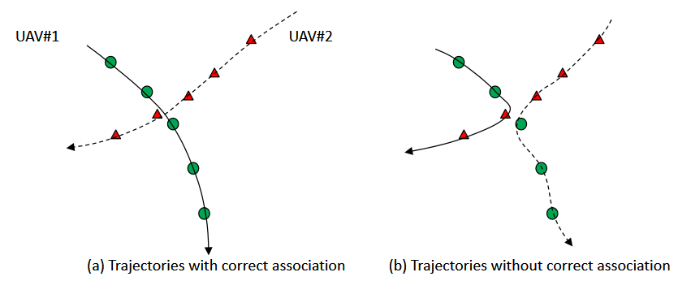
Figure 2.3.2.1-1 An example of the association problem using point cloud only
Our simulation results also shows the fact the it is very difficult to associate point clouds across different time into trajectories. Two drops simulations are carried on, and 15 UAV moving points with fixed 60 km/h are generated in each drop in one cell. After detected as point clouds with TRP mono-static sensing, trajectories are derived only with detected point clouds information (position, velocity), showing as Figure 2.4.2.1-2.
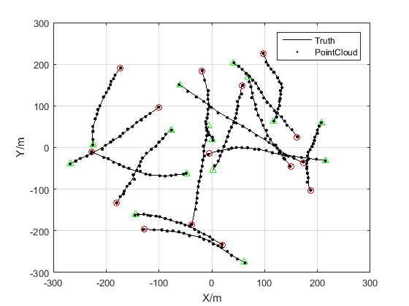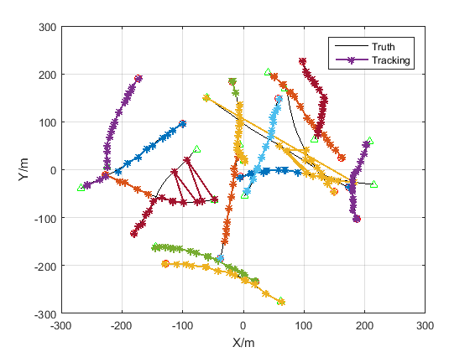
- (b)
Figure 2.3.2.1-2 (a) Sensing results of point clouds (b) Trajectories derived from point clouds
The simulation results shows that there is high probability to associate with wrong trajectories when trajectories intersect with each other if level C report is forwarded to SF.
As far as level-D measurement report, still some issues need to be solved during Rel-20 studied. Power metric of level-D measurement report shall be confirmed. The reported power would be one of important way for SF to know the size of detected target. For example, if radar cross section (RCS) of detected object could be derived and reported from RAN to SF, then SF could determine that there would be one large sensing target is located at the reported position if large RCS is reported.
For confidence metric and power metrilc of level D, we believe following quantity could be utilized:
- Confidence metric:
In principle, confidence metric could describe one uncertainty range of reported quantities as well as one possibility that the truth value is inside the uncertainty range. Such uncertainty range could refer to TS 23.032, in which the uncertainty range is usually described as uncertainty circle, uncertainty ellipse, uncertainty ellipsoid or even uncertainty arc. The example of uncertainty ellipse is shown as follows:

TS 23.032

5.3 Ellipsoid point with uncertainty ellipse
The "ellipsoid point with uncertainty ellipse" is characterised by the co-ordinates of an ellipsoid point (the origin), distances r1 and r2 and an angle of orientation A. It describes formally the set of points on the ellipsoid which fall within or on the boundary of an ellipse with semi-major axis of length r1 oriented at angle A (0 to 180º) measured clockwise from north and semi-minor axis of length r2, the distances being the geodesic distance over the ellipsoid, i.e. the minimum length of a path staying on the ellipsoid and joining the two points, as shown in figure 2a.
As for the ellipsoid point, this can be used to indicate points on the Earth's surface, or near the Earth's surface, of same latitude and longitude. The confidence level with which the position of a target entity is included within this set of points is also included with this shape.
The typical use of this shape is to indicate a point when its position is known only with a limited accuracy, but the geometrical contributions to uncertainty can be quantified.
Figure 2a: Description of an uncertainty Ellipse

Such uncertainty range could set one possibility that the truth value is located in such uncertainty range. Such possibility could be reported or set as default value, which could be 100%, 90% or some other value, and that value of possibility could be described as confidence, aligned with TS 23.032:

6.5 Confidence
The confidence by which the position of a target entity is known to be within the shape description, (expressed as a percentage) is directly mapped from the 7 bit binary number K, except for K=0 which is used to indicate 'no information' and 100 < K ≤128 which should not be used but may be interpreted as "no information" if received.

- Power metric:
Power metric for level D is also an important feature helping SF understand status of sensing target. For example, estimated RCS value could help SF to get the information on size of target. What’s more, some detected objects with extremely low power could also be considered as false alarms by SF.
In conclusion, report of power related confidence metric could benefit SF in at least following ways: (1) Distinguishing different targets with different RCS values, (2) Recognize false alarm with low received power.
During the discussion in RAN1#124 for 5GA ISAC, some different power metrics are proposed to be considered, including RSRPP, RCS, SINR and some other power related features. From our perspective, RSRPP are reasonable for level D report:
RSRPP: received reference signal power of detected path is typically used in CFAR algorithm. If some CFAR detection window shows positive, which means the detected received power in detection unit is larger than reference power, it shows that one object is detected in the range and/or Doppler bin of the detection unit. Therefore, it would be reasonable to use the power in detection unit, which is 2D bin in RD profile or delay bin in one dimension CIR (according to which option is selected), to derive RSRPP of sensing target for options of level D. For multiple TRPs in one aNB, a list of measured RSRPP from multiple TRPs are recommended to be reported for level D.
- 1D CA-CFAR (b) 1D OS-CFAR
(c) 2D CFAR
Figure 2.3.2.1-3 The illustration of different CFAR algorithm
Proposal 6: RAN1 should confirm at least parts of levels and options. Level D should be confirmed first, with confidence metric and power metric confirmed as following:
- Power metric: RSRPP.
- Confidence metric: Uncertainty range and related confidence value (if needed) for each reported quantity.

2.3.2.2. Measurement report from UE to RAN
Compared with measurement report from UE to SF, measurement report from UE to RAN would have following advantages:
- Low latency: The latency of UE based sensing measurement could be from two sources: (1) latency of transferring UE’s measurement to sensing measurement data processing node, e.g., SF or aNB. (2) latency of processing raw data to position and velocity of sensing target. If UE could only report measurement to SF, then the first latency for data transferring would be unacceptable. If UE would process sensing data locally, then the capability for processing data would be too much to UE and processing latency would also be unpredictable. Measurement report to aNB could utilize the the advantages on latency of physical layer report and high capability of processing sensing data on aNB.
- High accuracy: If sensing data could only be processed locally, limited by FoV of UE sensing and low transmitting power, accuracy of estimated parameters would be unsatisfying. If sensing data could only be processed on SF, then the lost information during quantization on sensing data from aNB and UE would limit the upper bound of sensing result. Processing on aNB locally for sensing data collected from aNB and UE would lever every local information and the cooperative sensing measurement to derive high accurate estimation on position and velocity of sensing target.
- Flexibility: aNB could allow flexible sensing RS configuration, such as semi-persistent or aperiodic sensing RS configuration. If aNB could access sensing report from UE, it could determine and activate most suitable RS configuration to UE according to current sensing performance. For example, if aNB recognize there is too much ambiguity from UE measurement, aNB could configure more dense RS resource to UE on time to increase sensing performance.
- Consistency with sensing assisted communication: aNB could be aware of environment information by UE’s directly measurement report. Such report could help aNB to manage communication parameters (e.g. beam, transmitting power) on time to fulfill the requirement of sensing assisted communication.
Therefore, given that the above advantages, UE’s sensing measurement to aNB should be supported. Considering the latency issues, and compatibility wiht sensing assisting communication, we believe sensing measurement report on layer-1 can be a starting point, similar as CSI reporting.
Proposal 7: RAN1 shall support UE to report sensing measurement to aNB.
- Layer 1 signaling similar as CSI measurement report could be a startomg point for UE location, delay/range, 3D angle, and Doppler report.

Sensing assisted communication
Sensing-assisted communication is an emerging field that integrates sensing technology with communication systems to optimize their performance by leveraging environmental information. Here are the main benefits:
- Enhanced Spectrum Efficiency: By sensing the surrounding spectrum usage, BS can dynamically adjust spectrum resource allocation, increasing spectrum utilization and reducing interference and resource wastage.
- Improved Communication Reliability: Sensing technology can monitor obstacles, interference sources, and the positions of mobile devices in real-time. This helps the communication system quickly adjust to avoid signal attenuation and loss, thereby improving communication reliability.
- Reduced Power Consumption: By sensing user behavior and environmental conditions, the communication system can dynamically adjust transmission power and other parameters, reducing unnecessary energy consumption and extending battery life.
- Optimized Network Resource Management: Sensing technology can provide real-time network status information, such as congestion, user distribution, and mobility patterns. This helps network operators manage and optimize resources more precisely.
- Support for New Application Scenarios: Sensing has broad applications in fields like autonomous driving, smart homes, and industrial IoT. For instance, in autonomous driving, vehicles can sense road and traffic conditions to optimize communication paths and transmission strategies, enhancing safety and communication efficiency.
In summary, sensing-assisted communication can significantly enhance the efficiency, reliability, and flexibility of communication systems by integrating sensing and communication technologies, addressing diverse future communication needs.

Use cases of sensing assisted communication

Sensing assists beam management
DL beam management is primarily based on the measurement of SSB and NZP CSI-RS. UEs perform L1 measurements to obtain quantities such as L1-RSRP and L1-SINR, which are reported alongside their corresponding beam identifiers, specifically SSB Resource Indicators (SSBRI) or CSI-RS Resource Indicators (CRI). To process these into a beam selection, the UE transmits these measurement reports to the gNB, which then chooses the most suitable base station transmission beam. Furthermore, if a CSI-RS resource set is configured with the repetition parameter set to 'on', the UE uses these resources to scan and select its own optimal spatial reception filter (UE Rx beam).
UL beam management relies on the SRS, specifically within SRS resource sets where the usage parameter is configured as 'beamManagement'. In this scheme, the gNB measures the SRS-RSRP (and potentially SINR) of the signals transmitted by the UE to assess the quality of different uplink spatial paths. The conversion from measurement to beam selection is performed by the gNB, which identifies the best uplink beam and communicates this choice back to the UE via an SRS Resource Indicator (SRI), a TCI state, or spatial relation information. Once the UE receives this indication, it applies the corresponding spatial domain transmission filter to physical channels such as PUSCH and PUCCH for future uplink transmissions.
The legacy beam management based on blind sweeping have following bottleneck:
- The overhead toll: as carrier frequency increase, e.g., 30GHz, beams would become narrower to overcome pathloss. The number of beams to be searched explodes, consuming vast spectral resources just to maintain alignment.
- The mobility bottleneck: The ‘sample and hold’ latency happens. By the time a UE measures CSI-RS, compute L1-RSRP/L1-SINR and transmits the report, high-mobility UE may have already exited the spatial filter, causing frequent misalignment and link failure. TRP mono-static sensing mode could help to track location of UE, then calculate best beam index without UE’s measurement report.
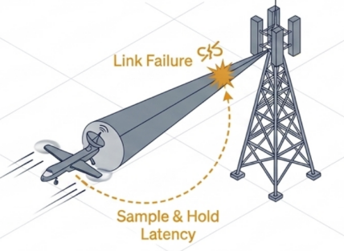
Figure 3.1.1-1 Link failure due to high mobility
TRP-UE bi-static sensing/UE bi-static sensing assists beam management:
Based on the configured sensing RS, base station could derive the point-cloud-like sensing measurements by UE->TRP bi-static sensing mode, or UE could report similar sensing measurements by TRP->UE bi-static sensing mode. Such sensing measurement would include several paths which are consisted of delay/range, power, 3D angle. Such rich information would accurately reflect the channel between UE and base station, and even the environment around the UE.
Based on such comprehensive sensing measurement, of course base station could calculate accurate beam index to be used. Given sensing operations, procedure of beam sweeping could be saved for lower spectrum efficiency, and higher accuracy of beam selection is possible because more information is used.
Figure 3.1.1-2 TRP-UE bi-static sensing assists beam management
TRP mono-static sensing assists beam management:
TRP mono-static sensing mode has the benefit that no UE measurement and report is needed while high accuracy channel information is still achievable. As long as base station could obtain UE’s location in some specific time point, base station could keep tracking the changes on UE’s location and environment around UE without extra UE’s measurements. Then base station could proactively calculate the best beam index to be used, providing stable beam selection especially for high speed UE when link failure happens. Communication latency could be saved a lot when traditional BFR frequently happens.
Figure 3.1.1-3 TRP mono-static sensing assists beam management
Benefited with rich information in sensing measurement, more accurate beam selection could be done with less measurement on beam sweeping. Authors in [2] uses sensing measurement in FR1 to estimate optimum beams of FR2, and achieves high spectral efficiency closed to ideal beam selection. Moreover, compared with normal FR2 beam sweeping in NR, 79.3% time overhead could be saved by FR1 sensing assistance.
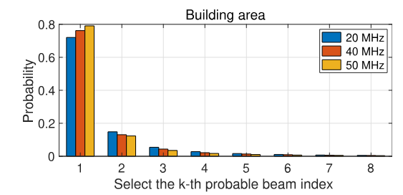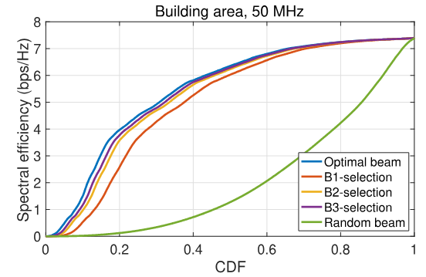
- (b)
Figure 3.1.1-4 (a) beam selection accuracy of the k-th probable beam index with N = 16 and sub-6 GHz bandwidths of 20, 40, and 50 MHz in the urban grid scenario (b) the CDF of spectral efficiency with sub-6 GHz bandwidth of 50 MHz in the urban grid scenario.
We further provide simulation results of sensing assisting beam management. Sensing assisting beam management can be typically applied to UMa and Urban Grid scenarios regarding vehicles as sensing target in TRP-UE bi-static sesning mode. Table 3.1.1-1 provides the detailed simulation assumption for sensing assisting beam management in Urban Grid scenario.
Table 3.1.1-1 Simulation assumption for sensing assisting beam management in Urban Grid scenario
Parameters | Values
ISAC use case | ISAC-Automotive
RS type | Pulse RS, CSI-RS
BS transmitting power | Same Tx power for both pulse RS and CSI-RS
In order to evaluated the performance of sensing assisting beam management, the beam management performance of pulse RS used as RS is compared with the beam management performance of CSI-RS, where the beam management performance of CSI-RS is used as the benchmark. In the following, two metrics regarding sensing assisting beam management are defined:
- Accurate ratio of communication beam selection
The receiver measures RSRPs of multiple beams with pulse RS as sensing RS. N beams corresponding to N maximum sensing RSRPs are selected as estimated communication beams, where N can be 1, 2, 3 or 4. If the N estimated communication beams include the true communication beam, it can be regarded as one accurate communication beam selection or successful sensing assisting beam management. Through counting multiple drops, the accurate ratio of communication beam selection can be obtained. Specifically, the true communication beam can be gotten by measuring maximum RSRP with CSI-RS as communication RS.
- CDF of RSRP gap of estimated communication beams
The gap of RSRPs between the estimated best communication beam and the estimated second best communication beam can be calculated. Similarly, the gap of RSRPs between the true best communication beam and the true second best communication beam can be calculated. Then, the CDF of RSRP gap of estimated beams can be compared with that of RSRP gap of true beams.
In the section, the simulation results regarding the two defined metrics for sensing assisting beam management are provided. Table 3.1.1-2 shows the accurate ratio of communication beam selection, which shows the pulse signal can be used for beam selection. Figure 3.1.1-5 shows the CDF curves of RSRP gap between top-2 beams using pulse RS and CSI-RS, which demonstrates the similar effect on best beam caused by the second best beam using pulse RS and CSI-RS.
Simulation results in transmission power case 1:
Table 3.1.1-2 Accurate ratio of communication beam selection
Value of N | Accurate ratio of communication beam selection
N=1 | 94.00%
N=2 | 94.00%
N=3 | 97.05%
N=4 | 97.39%
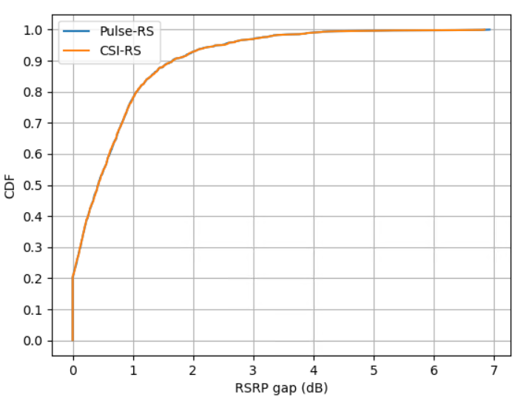
Figure 3.1.1-5 CDF curves of RSRP gap between top-2 beams using pulse RS and CSI-RS

Observation 1: Measurement of sensing modes of TRP-UE bi-static, UE-bi-static, and TRP mono-static could be beneficial for beam management:
- Sensing measurement would include rich information on paths of environment. Beam selection could be finished accurately with fewer sensing RS resource to save the overhead for beam sweeping for high frequency.
- For TRP mono-static sensing, aNB could obatin the characteristic of environment, and schedule optimistic beam before UE’s measurement report if knowing with UE’s location. Stable beam selection and connection could be ensured especially for high speed UE when link failure happens frequently.
- Pulse signal can be used for communication beam selection with an accurate ration ≥ 94%.

Sensing assists CSI measurement
Under the 5G NR CSI feedback framework, the UE evaluates the downlink channel through reference signals and reports the Rank Indicator (RI), Precoding Matrix Indicator (PMI), and Channel Quality Indicator (CQI) to facilitate link adaptation and beamforming at the gNB
- RI indicates the number of transmission layers, or independent data streams, that the UE recommends for downlink transmission based on the current channel's spatial multiplexing capability
- PMI points to a specific precoding matrix within a configured codebook—such as the standard-resolution Type I or high-resolution Type II—that the base station should use to focus signal energy toward the UE. The PMI often comprises wideband components describing the spatial beam direction and a subband component used for co-phasing across polarizations or fine-tuning based on frequency-selective fading.
- CQI is calculated conditioned on the suggested RI and PMI, representing the highest modulation scheme and target code rate that can achieve a transport block error probability not exceeding a specific threshold.
Together, these feedback elements provide the base station with a complete recommendation for the spatial rank, beamforming weights, and data rate for efficient downlink data scheduling.
Basically, the following sensing measurement could be reported align with traditional CSI report:
- Angle: NR type-2 codebook could be reused for sensing measurement on multipath components. For each sensing ray, multiple precoding vector could be reported as one combination as following:
Where is be spatial beam vector, which could be reported as codebook indices and . is amplitude for beam i, using as the weight of beam i to describe the estimated angle. Wideband amplitude and subband amplitude could describe amplitude together. is phase coefficient of each beam i, and phase indicator could be reported to map the value of .
- Delay: Starting from Rel-16, the codebook evolved to use FD Basis Vectors to compress frequency-selective feedback. UE reports frequency domain basis vectors ( DFT vectors selected via and ) to represent frequency variations. Such report has granularity of subband, or half of subband, which is configured by length of frequency domain basis vectors. Such sparse report would not be enough for sensing report requiring high accuracy of delay measurement, thus some more enhancement needs to be studied for sensing.
- Doppler: Roughly quantized Doppler report in CSI measurement is also supported in Rel-18 MIMO. For sensing, the granularity is much finer. Each Doppler frequency could be represented by one DFT vector on time domain, with granularity of level of OFDM symbol, depending on RS period. Similar design on Delay/Angle report could be studied for Doppler report.
Figure 3.1.2-1 Sensing assists CSI measurement with finer granularity
In short, for sensing assists CSI measurement, integrating UE sensing measurements, such as those derived from large-bandwidth and multi-port sensing RS, into the CSI feedback framework offers significant advantages over conventional reporting. While traditional RI, CQI, PMI provide quantized recommendations based on dominant channel components, sensing metrics including precise path power, delays, 3D angles could reconstruct the physical channel with far greater granularity. This allows the aNB to optimize precoding not just through a predefined codebook, but by accurately targeting or nulling specific physical paths, thereby enhancing multi-user interference suppression and overall spectral efficiency. By aligning the spatial domain filters more closely with the actual multipath geometry, this approach ensures more stable link adaptation and superior beam tracking in complex, dynamic environments.
Observation 2: Sensing measurement report from UE could be reused for CSI measurement usage with following benefits:
- Resource reusing: Sensing RS could be resued for communication assistance without invloving more overhead.
- Better accuracy: Sensing measurement report has better resolution and accuracy on delay/Doppler/angle measurement. aNB could make better precoding with such comprehensive information.

Proposal 8: Study signaling and network structure for sensing assisted communication considering following use cases:
- Sensing assists beam management
- Sensing assists CSI measurement
To support sensing assisted communication, RAN1 should support that:
- UE reports sensing measurement directly to aNB
- aNB obtains UE’ s location information for communication assistance while protecting the UE's privacy

Latency analysis on network structure for communication assistance
For communication service, parameters and resources are configured by aNB. To support sensing-assisted communication, it should let aNB get some sensing information, including UE’s sensing measurement report. During discussion in RAN1#124bis, two following potential structure for aNB accessing UE’s sensing measurement report are proposed to be studied. Follows are our analysis on them.
- Option 1A: The UE measurements and/or assistance information if needed from UE can be directly sent to aNB
To reduce signaling overhead and achieve rapid sensing results at aNB side, the direct sensing measurement report from UE to aNB is needed. To address UE privacy issue, the following procedures can be considered:
- Step 1: The aNB requests sensing measurement results related to a specific UE from the SF. The request information may include UE ID, beam direction, resource index of sensing reference signals (which requires measurement results for these resources), TRP ID, cell ID, and the required type of measurement report (e.g., beam information, time, speed, or power).
- Step 2: The SF side performs authentication and authorization to determine whether it can provide the sensing results of the UE to the aNB.
- Step 3: The SF responds to the aNB, indicating whether it can provide the sensing results. The response information may also include some detailed signaling, such as which sensing results can be provided to the base station and which cannot.
- Step 4: The SF requests the UE to directly report sensing results set A’ to the aNB. For timeliness, this reporting can be done at the physical layer. The request information may include beam direction, resource index of sensing reference signals (which requires measurement results for these resources), TRP ID, cell ID, and the required type of measurement report (e.g., beam information, time, speed, or power).
- Step 5: The UE directly reports sensing results set A to the aNB in physical layer. Note that set A and set A’ may not be completely identical, depending on the UE's reporting resources, capabilities, etc. The aNB can use this part of the sensing results to assist in communication scheduling.
Figure 3.2-1 BS request sensing results from UE reported in physical layer for assisting communication
Based on UE’s sensing measurement report directly to aNB by physical layer, the latency for aNB to access UE’s sensing measurement report would only include the transmission latency during UE and RAN in L1, and DU processing time .
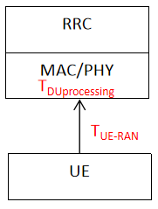
Figure 3.2-2 Signaling structure of UE’s sensing measurement report directly to aNB by L1 signaling
Based on the observation in TR 38.857, following analysis on MAC/PHY signaling latency could be referred. In average only =1~3.5 ms latency happens when UE sends sensing measurement directly to aNB by L1 signaling. Therefore, aNB would optimize communication configuration in time benefiting by such a low latency.
TR 38.857
8.1.3.2 Latency analysis for UL-TDOA/UL-AoA
......
Step 7 MAC Activate UE SRS transmission | 1-3.5 | Processing delays: 1-3ms  - UE: T_{UEProc-MAC-SRSAct}  Signalling delay:0-0.5ms  - UE-gNB: T_{UE-gNB}  Note 5: Should not be counted if the periodic or aperiodic SRS is used.

- Option 1B: The UE measurements and/or assistance information if needed from UE can be sent to SF
In this case, aNB should request UE’s sensing measurement from SF. The signaling structure is shown as following:
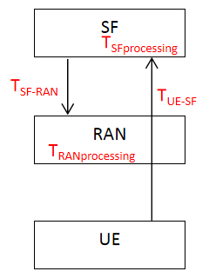
Figure 3.2-3 Signaling structure of UE’s sensing measurement report directly to aNB by L1 signaling
This method is straightforward and has minimal impact on the RAN-side air interface. However, the communication timeliness between the aNB and the SF may be poor. The transmission latency would at least include the transmission delay from UE to SF, processing time on SF , transmission delay from SF to RAN and processing time on RAN . According to analysis in TR 38.857, + could refer to LPP signaling which provides location information to LMF, and + could refer to NRPPa signaling from LMF to RAN node. Considering there may be a case that no more AMF is involved between aNB and SF, extra 5ms could be saved for each link.
TR 38.857
8.1.3.2 Latency analysis for DL-TDOA/DL-AoD
......
Step 8 LPP Provide Location Information | 20-39.5 | Processing delays: 16-19 ms  - UE:  - T_{UEProc-RRCULInfo}  - T_{UEProc-LPPLocationRe}  - gNB: T_{gNBProc-NAS/LPP}  - AMF: T_{AMFProc}  - LMF: T_{LMFProc}  Signalling delay:4-20.5 ms  - UE-gNB: T_{UE-gNB}  - gNB-AMF: T_{gNB-AMF}  - AMF-LMF: T_{AMF-LMF}
8.1.3.2 Latency analysis for UL-TDOA/UL-AoA
......
Step 3 NRPPa POSITIONING INFORMATION REQUEST | 13-29 | Processing delays: 9 ms  - gNB: T_{gNBProc-NRPPa}  - AMF: T_{AMFProc}  - LMF: T_{LMFProc}  Signalling delay:4-20 ms  - gNB-AMF: T_{gNB-AMF}  - AMF-LMF: T_{AMF-LMF}

In conclusion, total latency of option1B for aNB to access UE’s measurement report would be derived as
Such high latency would be unacceptable for sensing assisting communication targeting on high-speed UE. To enable sensing assisting communication, one unified network structure should be used for both low-speed UE and high-speed UE. In dynamic mobile environments, particularly in high-frequency (FR2) scenarios, the spatial characteristics and channel state can vary significantly within a few milliseconds. By the time the gNB receives the sensing report, the UE’s sensing measurement may no longer align with the actual physical environment or UE location, which can lead to severe beam misalignment, and a general reduction in spectral efficiency.
Furthermore, since legacy CSI measurement feedback are based on L1 signaling, typically much shorter, adding a reporting delay of nearly 60 ms exceeds the coherence time of most terrestrial channels, rendering such sensing-based assistance far less effective for real-time link adaptation and beam tracking compared to traditional L1/L2 feedback mechanisms. In this case, sensing measurement by UE from SF would be helpless for sensing assist communication.
Observation 3: The latency for aNB to access UE’s sensing measurement report is estimated at least as following:
- Option1A (UE measurement directly sent to aNB):
- Option1B (UE measurement sent to SF, and then from SF to aNB):
Latency of Option1B would be much longer than normal L1 measurement report for beam management and CSI measurement feedback. For sensing assisting communication, aNB does not expect to receive sensing measurement report of UE with more latency compared with normal communication procedure. Huge latency would make UE measurement report from SF helpless for communication assistance.
Proposal 9: For sensing assisted communication, UE directly reports sensing measurement data to aNB.

RS for sensing

Enhanced RS for sensing
Communication RS, such as CSI-RS and TRS could be reused for sensing by continuous RS in near area. Its mapping to the resource grid is primarily defined by the number of antenna ports, frequency density, and time-domain behavior (periodic, semi-persistent, or aperiodic). However, at least following issues should be considered to fit the performance requirement.
- Limitation on comb size in frequency domain
There is a trend in 6G communication to increase the comb size of CSI-RS to increase the number of multiplexed users. In 5G, the comb size of 6G CSI-RS is 4. As shown in Fig. 3.1.2.2-2, the comb size of 4 leads to 4 ambiguous range region, which is exactly the same. That is to say, the sensing algorithm cannot identify which ambiguous range region the target is in, which will leads to a very large sensing error and affects both false alarm rate and detection rate. Assuming a sub-carrier frequency spacing of 30kHz, the maximum unambiguous range is 1.2km, which cannot satisfy the coverage requirement of RMA. Therefore, one of enhancements of the communication RS is to have a small comb size, e.g., 2.
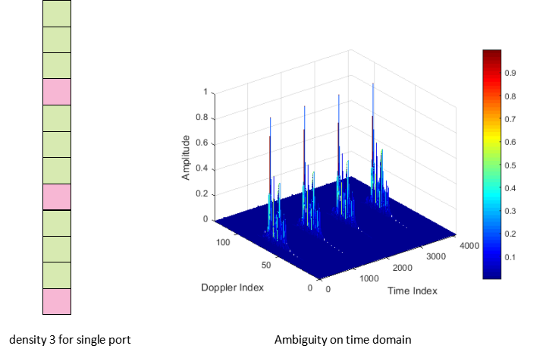
Fig. 4.1-1 The ambiguous issue for CSI-RS with a comb size of 4.
- Limitation on time domain density
In 5G NR, the time domain density are only configured for periodic and semi-persistent CSI-RS and TRS:
- CSI-RS: time domain density is configured by high layer configuration CSI-ResourcePeriodicityAndOffset and configurable periodicity include 4, 5, 8, 10, 16, 20, 32, 40, 64, 80, 160, 320, and 640 slots.
When single port transmission is used, maximum frequency could be used, and 1 OFDM symbol could be occupied in one slot. It means that the single port CSI-RS in NR could be configured as one uniform RS with minimum time periodicity of 4 slots.
- TRS: For NZP CSI-RS configured by the TRS-ResourceSet IE, the density and number of ports . However, TRS could be measured combined with 4 or 2 TRS together.
- For FR1, four periodic TRS in two consecutive slots with two periodic TRS resources in each slot could be configured. If no two consecutive slots are indicated, two periodic TRS resources in one slot could be used.
- For FR2, UE could be configured with two periodic TRS resources in one slot or four periodic TRS resources in two consecutive slots with two periodic NZP CSI-RS resources in each slot.
Inside each slot, every TRS resource set usually indicate the OFDM symbol location of first TRS resource by RRC configuration firstOFDMSymbolInTimeDomain, and second TRS resource in the same slot can be derived implicitly with symbol index as firstOFDMSymbolInTimeDomain+4.
To enable UE could coherently measure the TRS resources in one TRS resource set, all TRS resource in one TRS resource set could assume the antenna ports are same.
For each TRS resource, the configurable periodicity is restricted to 10, 20,40, 80, 160, 320, and 640 slots. It means that each TRS resource set could configured as non-uniform RS with one large periodicity of at leat 10 slots, and 4 OFDM symbols in two consecutive slots could be occupied for sensing in each period.
Fig. 4.1-2 Non-uniform RE pattern of TRS
Observation 4: Both CSI-RS and TRS don’t support sufficient frequency domain density and time domain density for tracking on high speed target without ambiguity.
- Comb size 4 for CSI-RS or TRS
- Period of CSI-RS: 4, 5, 8, 10, 16, 20, 32, 40, 64, 80, 160, 320, and 640 slots
- Period of TRS: 10, 20,40, 80, 160, 320, and 640 slots
  - In each period, at most four periodic TRS in two consecutive slots with two periodic TRS resources in each slot could be configured.

Proposal 10: Considering at least the following aspects for enhancements on CSI-RS or TRS:
- Comb size reduction, e.g., comb-2 in frequency domain.
- Time density reduction on communication RS is not supported because of high and unacceptable overhead.

Non-uniform RS

Metrics
Even nonuniform RS pattern could provide higher unambiguous detection range with less spectrum occupation, some other drawbacks such as sidelobe to counteract its benefit. Therefore, following metrics should be used to analysis the characteristics of non-uniform RS.
If sensing RS in non-uniform pattern in time domain, it can be assumed that the sensing RS is repeated transmission with a large period of with totalperiods. During each period, the non-uniform sensing RS is transmitted at time point, referred to the starting point of each period.
- Unambiguous Doppler range
For non-uniform sensing RS, the maximum unambiguous Doppler is not determined by the smallest spacing. Instead, it is governed by the greatest common divisor (GCD) of all time intervals — i.e., the finest "common time grid" on which all sampling instants align.
The maximum unambiguous Doppler frequency range is

- Doppler resolution
The Doppler resolution is only decided by the total length of measurement window in theoretically. No matter which pattern is used, Doppler resolution is still calculated as
- Peak sidelobe level ratio (PSLR)
PSLR is determined by the sampling pattern's "window". Given a sampling sequence , its spectrum, which is the ambiguity function in Doppler domain, is shown as following:
The PSLR determines the level of spurious peaks and related false alarms.
- For uniform sensing RS, PSLR is zero.
If uniform sensing RS is used, sidelobe, which means , only happen when . Considering the PSLR is only calculated inside unambiguous Doppler range, which is , no sidelobe could be observed, and PSLR is zero.
- For non-uniform sensing RS, PSLR is decided by its RE pattern.
Considering the M period with , the ambiguity function for non-uniform sensing RS should be given by samples:
Whendoes not form an arithmetic sequence, these spurious peaks are scattered throughout the unambiguous range. If spurious peaks is too high, it may cause false alarm in Doppler domain for each target, showing such a non-uniform pattern is unacceptable.

Observation 5: Assuming the sensing RS is repeated transmission with a large period of with totalperiods. During each period, the non-uniform sensing RS is transmitted at time point, referred to the starting point of each period. Following metrics should be considered for non-uniform RS design:
Unambiguous Doppler range |  | The maximum Doppler frequency span that can be measured without aliasing. For non-uniform RS, it is determined by the GCD of all sampling intervals, and can far exceed the uniform-sampling limit .
Doppler resolution |  | The minimum distinguishable frequency separation between two Doppler components.
Peak sidelobe level ratio (PSLR) |  | The PSLR is ratio (in dB) of the highest sidelobe to the main peak of the ambiguity function. A lower PSLR means better suppression of spurious peaks and more reliable target detection.

Joint sensing RS set
5G NR uses one specific RS types for a specific functionality. For 6G, more functionality like sensing is introduced, and the RS should avoids complex and case-by-case design. Multiple types of RS could be aggregated together as one sensing RS set for sensing measurement, and multiple different RS resources of one type of sensing RS could also be aggregated.
- Joint sensing RS set with multiple types of RS
Multiple types of RS, e.g., RS used for CSI measurement, positioning, beam management and so on, could be configured together sensing usage. Such joint sensing RS set could could indicate different RS resource of different types of RS are involved together for sensing measurement. First of all, inherently, multiple types of RS in one joint sensing RS could be still used for its original usage. Measurement on different RS in one joint sensing RS set should be coherently processed together to derive sensing measurement values, e.g., position, delay/range, Doppler/velocity, 3D angles. Based on the combination of different types of RS, higher sensing performance could be expected with fewer wireless resources by such nonuniform design.
With multiple types of RS configured together, flexible frequency and time domain allocation by one unified frame work could also be enable, which not only benefit for sensing, but also for communication. For example, such combined frequency and time domain allocation could enable flexible interference mitigation.
Figure 4.2.2-1 Example of joint sensing RS set with multiple types of RS
- Joint sensing RS set with multiple RS resources of one type of RS
Communication requires a large amount of resources to carry data transmissions, while sensing requires a large amount of resources to form a large sensing aperture. In order to ensure the sensing performance with a simple processing, the uniform RS pattern should be first supported. Then, for the resource-limited cases, in order to form a large sensing aperture, the non-uniform RS pattern can be studied. Such nonuniform RS pattern would usually be time domain spares pattern, and it would be hard to indicate occupied REs if frequent domain spares pattern is used. Such sparse pattern in time domain are good way to expand the sensing aperture.
Joint sensing RS set could be one solution for nonuniform RS pattern. Inside one joint sensing RS set, different RS resources of same type of RS could be configured with different time offset. By different and nonuniform time offset, multiple RS resources could be located on OFDM symbol domain randomly, enable one time domain spares pattern.
Figure 4.2.2-2 Time domain spares pattern by joint sensing RS set
Proposal 11: Study joint sensing RS set with at least following two methods:
- Joint sensing RS set with multiple types of RS, e.g. using CSI-RS, Pulse RS, and PTRS together for sensing measurement.
- Joint sensing RS set with multiple RS resources of one type of RS, e.g., CSI-RS resources with different time offset for time domain sparse pattern.

Power control

UL power control
Currently, UL transmission power control is well supported in NR specification. One example is for positioning SRS power control in the current 3GPP TS 38.213 below.
If a UE transmits SRS based on a configuration by SRS-PosResourceSet on active UL BWP $b$ of carrier $f$ of serving cell $c$, the UE determines the SRS transmission power $P_{SRS,b,f,c}\left(i,q_{s}\right)$ in SRS transmission occasion $i$ as
[dBm]
where,
- $P_{O_SRS,b,f,c}\left(q_{s}\right)$ and $α_{SRS,b,f,c}\left(q_{s}\right)$ are provided by p0-r16 and alpha-r16 respectively, for active UL BWP $b$ of carrier $f$ of serving cell $c$, and SRS resource set $q_{s}$ is indicated by SRS-PosResourceSetId from SRS-PosResourceSet, and
- ${PL}_{b,f,c}\left(q_{d}\right)$ is a downlink pathloss estimate in dB calculated by the UE, as described in clause 7.1.1 in case of an active DL BWP of a serving cell $c$, using RS resource indexed $q_{d}$ in a serving or non-serving cell for SRS resource set $q_{s}$ [6, TS 38.214]. A configuration for RS resource index $q_{d}$ associated with SRS resource set $q_{s}$ is provided by pathlossReferenceRS-Pos
- if a ssb-IndexNcell is provided, referenceSignalPower is provided by ss-PBCH-BlockPower-r16
- if a dl-PRS-ResourceId is provided, referenceSignalPower is provided by dl-PRS-ResourcePower
However, it may not be applicable well for sensing in ISAC system. When a UE transmits a sensing reference signal (RS) to BS (base station), the BS needs to detect the receiving signal and extract the signal passing through a sensing target. This signal passing through the sensing target suffers more propagation loss because of RCS loss. How to control the transmission power of UL sensing RS is unclear.
As shown in the following figure, for UE->BS sensing mode, UE transmits UL sensing RS, then BS needs to detect if there is a car in the sensing area and the location of the car based on the receiving UL sensing RS. The key issue is to extract the sensing path which is usually very lower power than the LOS path between the UE and BS.
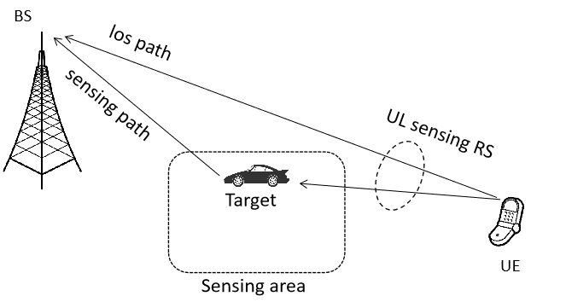
Figure 4.3.1-1 Sensing mode of UE transmitting and BS receiving (UE->BS sensing mode)
However, the traditional NR power control mechanism is trying to control the total receiving power meeting the requirement. It is not applicable for sensing. For example, the existing NR pathloss (PL) computation is
PL = Transmission power - Receiving RSRP
where the receiving RSRP is average power across all REs in frequency domain which includes all links or paths between UE and BS.
For sensing, the channel link that the receiver needs to utilize is the Tx-ST-Rx link, from which the receiver extracts the channel of the sensing target. The power of the LOS path between Tx and Rx, no matter how strong, is useless for sensing purposes and is merely considered as background clutter.
In other words, the power control for uplink sensing Reference Signals (RS) mainly focuses on regulating the power associated with the Tx-ST-Rx path, i.e. the link from the UE, passing through the sensing target (ST), and further to BS, rather than focuses on the total power. The primary objective is to ensure that the path useful for sensing meets the requirements when it arrives at the receiver.
Observation 6: For sensing mode of UE->BS, the motivation is to control the UE transmission power so that the receiving power of the path UE-ST-BS meets the need.
- For the paths not related to UE-ST-BS, e.g. LOS link between UE and BS is useless information
To efficiently control the transmission power on the sensing target related paths, one solution is to introduce RSRPP based power control of sensing transmission signal. Specifically, the PL computation is based on specific path or paths. In implementation for sensing, the PL = Transmission power - Receiving RSRPP where the RSRPP is the receiving power in specific path or paths.
For example, the UE transmission power $P_{Sen\sin{g}RS}$ is based on the following formula which is similar as NR positioning SRS power control. As shown in the following figure, the PL computation is based on the RSRPP in specific paths.
$$P_{Sen\sin{g}RS}=\min\left\{\begin{aligned}P_{CMAX} \\ P_{O_{S}en\sin{g}RS}+10\log_{10}{(}2^{μ}⋅M_{Sen\sin{g}RS})+α_{Sen\sin{g}RS}⋅PL\end{aligned}\right\}[dBm]$$
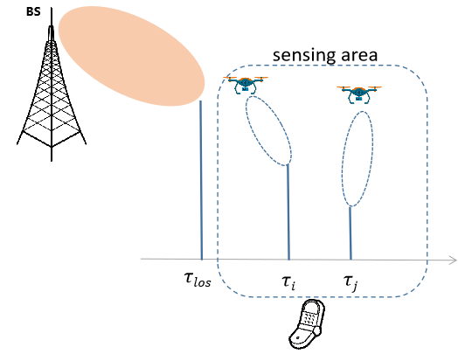
Figure 4.3.1-2 Sensing mode of UE transmitting and BS receiving (UE->BS sensing mode)
In short, the PL for sensing now is the propagation loss on the paths passing through the potential sensing targets, which excludes the paths of clutters. Then, the UE transmission power is trying to compensate the pathloss on those useful paths for sensing. The receiving power of the sensing signal on the Rx-ST-Tx paths can be controlled as network wants to meet the sensing requirement. In other words, if the existing NR power control mechanism is completely reused, the receiving power at BS side may not be sufficient.
Proposal 12: Study new power control mechanism for UL sensing signal, such as RSRPP based pathloss computation, etc.

DL power control
Downlink power control on sensing should consider the effect of sensing target reflecting, calling for different downlink power control configuration compared with communication. It should be pointed out that DL transmitting power of sensing signal should be noticed on UE, because that UE may use one threshold of absolute receiving power to distinguish false alarm and such threshold should be updated based on transmitting power.
Current DL power control is mainly based on the transmitting power of SSB and power offset of typical RS. For example of CSI-RS, ss-PBCH-BlockPower, which is transmitting power of SSB should be firstly configured to UE, and RRC configuration of powerControlOffsetSS would indicate the power offset between NSP-CSI-RS and SSB.
For sensing usage, sensing RS should be transmitted by Tx, reflected by sensing target and then received by Rx. Such reflecting loss by sensing target, and extra transmitting distance would call for different DL power control configuration for sensing RS. Therefore, dedicated power offset on RS used for sensing should be considered. Even some RS, e.g. CSI-RS, TRS, could be used for sensing usage, the transmitting power would be still different when it is used for sensing measurement. One dedicated power offset for RS used for sensing should be necessary, which is independent on power offset for communication. Therefore, for those communication RS reused for sensing, power offset configuration for communication and for sensing should be provided separately.
In conclusion, dedicate DL power control scheme for sensing is necessary, and we have following proposal:
Proposal 13: Determine the DL transmission power for sensing dedicated RS independently of communication.

Sensing processing

Coherent processing interval (CPI)
Different from RRM measurement and positioning measurement, the sensing measurement can be Doppler or speed, besides timing related measurement (TOA), angle related measurement (AOA, ZOA) and power related measurement (RSRP, SINR, RSRQ). The timing related measurement, angle related measurement and power related measurement can be obtained by processing sensing RSs in a single reception instance. But Doppler or speed related measurement is obtained by jointly processing sensing RSs in multiple reception instances, which needs longer time to measure and process sensing RS. In the study of 5G-A sensing, coherent processing interval (CPI) is introduced as a minimum time unit to derive one set of measurement report including delay, angle, Doppler and any other physical quantities.
During sensing measurement for detection and tracking, aNB or UE would measure repeated reference signal in one CPI, and process the received signal coherently to obtain one estimated shot of position and velocity of sensing target. Such coherence could be destroyed if configuration of sensing RS is changed. For example, if TA is changed scheduled by DCI, then one unpredictable skip on phase measurement of each path would happen, and accuracy of Doppler estimation would be affected a lot. Changes on other parameter which would cause complex phase step change are listed as following:
- TA, transmitting power, TCI status, antenna ports, period of sensing RS, time and/or frequency allocation of sensing RS......
As long as aNB still need the UE to keep continuing current sensing task, changes on such above parameters would be unacceptable during one CPI. Even aNB provides the scheduling signaling to modify some of parameters, the true intent of aNB could be configuring sensing measurement for next CPI, showing as following:
Figure 5.1-1 Postponed scheduling in one CPI
Therefore, depending on intent of aNB, if aNB decides to drop all sensing measurement data of current CPI, UE shall adopt all configurations scheduled by aNB even the scheduling signaling is received during one CPI, and if aNB decide to continue sensing measurement of current CPI, UE shall postpone to activate the scheduled configurations at least until current CPI ending. From RAN1 perspective, how to make sure UE could understand whether aNB decide to drop sensing measurement of one certain CPI and when to activate scheduled configurations should be studied in 6G.
Proposal 14: RAN1 should study the configurations of coherent processing interval (CPI) for UE, e.g. how to ensure coherence of TA, power, etc. during one CPI for sensing measurement.

Beam management for sensing
Different with communication, detection on multiple sensing targets would call for more sophisticated beam management. It is because communication would only need to determine one best DL/UL beam pair with ideal channel response, while multiple DL/UL beam pairs could be needed simultaneously targeting on multiple sensing targets. Therefore more complicated beams management procedures need to be studied for 6G. From ZTE’s view, there are following potential scenarios during sensing measurement.
- Multiple TRP transmitting beams paired with one UE receiving beam: There is no much effect on beam management. aNB could configure different RS resource with TCI states with same spatial Rx parameters.
- Multiple TRP receiving beams paired with one UE transmitting beam / one TRP receiving beams paired with multiple UE transmitting beams : It could be aNB implementation. The only thing for aNB to do is configure UE to transmit UL sensing RS resources with one/multiple Tx spatial filter and receive the signal with different/same receiving beams.
- One TRP transmitting beams paired with multiple UE receiving beams: This scenario could be shown as following figure:
Figure 5.2-1 Sensing measurement by multiple receiving beams paired with one TRP transmitting beam
In this scenario, one sensing RS resource should be received with multiple UE receiving beams, and UE should report sensing measurements with multiple different receiving beams. Currently such requirement could not be meet for all candidates of sensing RS.
NR PRS measurement could be studied for sensing. During UE is doing NR DL-AoD Positioning, UE is allowed to report multiple NR-DL-AoD-AdditionalMeasurementElement-r17 with NR-DL-AoD-MeasElement, and each NR-DL-AoD-AdditionalMeasurementElement-r17 could support to report independent nr-DL-PRS-ResourceID and nr-DL-PRS-RxBeamIndex (ranges from 1 to 8). UE could measure and report the measurement with same PRS resource with same ID and different nr-DL-PRS-RxBeamIndex in one report to LMF.
Current NR RS except for PRS cannot be reported with such method. As an example, NZP-CSI-RS-Resource for periodic CSI-RS would directly configure one qcl-InfoPeriodicCSI-RS to indicate one TCI state. For semi-Persistent CSI-RS, aNB could send SP CSI-RS/CSI-IM Resource Set Activation/Deactivation MAC CE to activate one CSI-RS resource set. In this MAC CE, only one TCI State IDi would be mapped with one CSI-RS resource. For aperiodic CSI-RS, base station would configure qcl-info in CSI-AperiodicTriggerState, in which RS resource would be mapped with TCI-StateID one by one.
Only when the UE is configured with higher layer parameter NZP-CSI-RS-ResourceSet and when the higher layer parameter ‘repetition’ is set to 'on', UE actually could measure single CSI-RS with multiple beams, but specification demand that CRI for the CSI-RS Resource Set for channel measurement is not reported, and UE would only decide its receiving beam. In this case, all CSI-RS resource in one resource set would share same transmitting beam, which is lack of dynamics.
Therefore, beam management for sensing may need be studied for multiple sensing target scenario to let UE could find multiple beam direction, even some of beam direction would not targeting on the direction with maximum receiving power. Then base station could configure multiple beam directions for repetitions of one single sensing RS. Then if still reference RS is used to indicate beam direction and other configurations, it should be allowed that more than one transmitting/ receiving beam directions could be mapped with one or more reference RS(s). Otherwise, UE could also report beam management for multiple sensing target with directly spatial parameters, e.g. 3D angle. Then aNB could directly configure multiple beam direction for one single sensing RS without reference RS.
It should be noted that such beam configuration could still be realized by configuring same transmitting beams for different CSI-RS resource with different mapped TCI-state, or allowing higher layer parameter ‘repetition’ could be ‘on’ while CSI-RS resource still keeps sweeping transmitting beams. Such methods do not need further specification impact, and then RAN1 should study whether such methods can meet the requirement of sensing.
Proposal 15: For beam management, RAN1 should study whether and how to enhance beam configuration for multiple sensing targets scenarios, e.g., directly configure 3D angles of beam directions mapped with one sensing RS.

Interference measurement and mitigation

Interference types
Generally, there are six types of interference: BS self-interference, BS-BS interference, BS-UE interference, UE-BS interference, UE self-interference, UE-UE interference. From our view, the first three types of interference are more severe in ISAC system for those promising use cases, e.g. UAV tracking. The details are provided in the following table:
Table 4.3.1-1 Interference types for ISAC
Interference type | Details
BS self-interference | For BS mono-static sensing mode, the BS is required to transmit and receive the sensing RS simultaneously (radar like sensing). The component that leaks directly from the Tx antenna to the Rx antenna is self-interference, while the component reflected/scattered/diffracted by the environment or target is a useful signal for sensing. Such interference could be mitigated by large antenna isolation or removed by pulse signal allowing transmitting and receiving asynchronously.  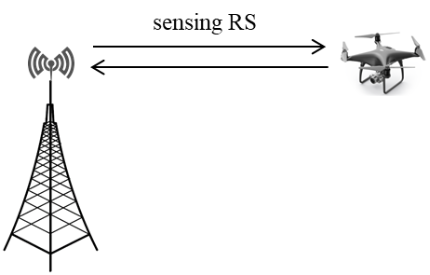  Figure 4.3.1-1 BS self-interference
BS-BS interference | - Case 1: Interference between sensing and communication.  - DL sensing RS transmissions in the adjacent cells interfere with the UL communication signal/channel(s) reception of TRP (as shown in Figure 2.6.1-2).  - DL communication signal/channel transmissions in the adjacent cells interfere with the UL sensing RS reception of TRP.  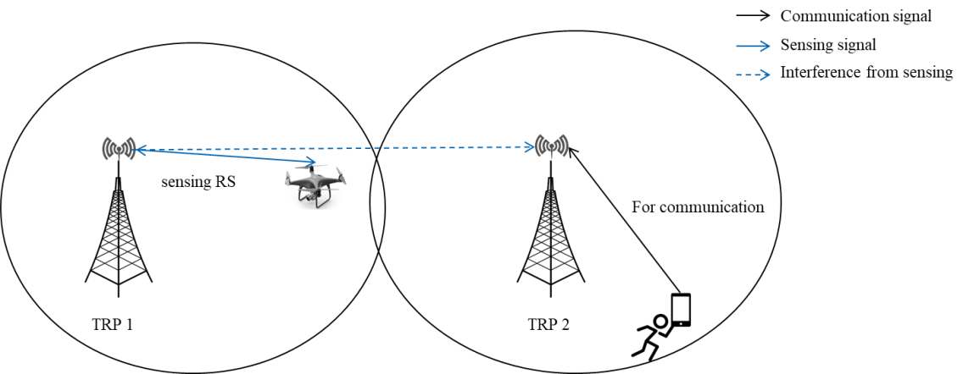  Figure 4.3.1-2 DL sensing RS transmissions in the adjacent cells interfere with the UL communication signal/channel(s) reception of TRP 2  - Case 2: Interference between different sensing nodes  - DL sensing RS transmissions in adjacent cells interfere with the UL sensing RS reception of a TRP.  - Two BS for mono-static sensing interfere with each other (as shown in Figure 2.6.1-3)  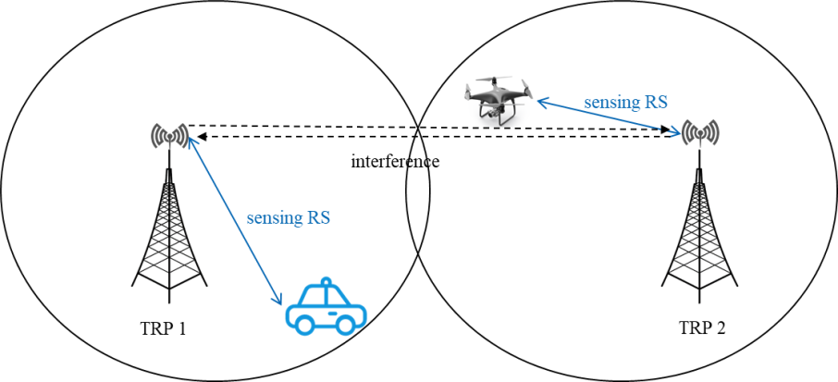  Figure 4.3.1-3 sensing BS-sensing BS interference
BS-UE interference | This interference is similar as the DL interference type in legacy TDD network with static TDD UL/DL configuration, however, the BS-UE interference can be more severe for ISAC.  As shown in Figure 2.6-4, for detecting or tracking UAV, the coverage of sensing and communication can be different, the DL sensing RS aiming at low altitude airspace transmitted by TRP1 can interfere with UE under TRP2’s coverage.  Specifically:  - Case 1: Interference between sensing and communication:  - DL sensing RS transmissions in the adjacent cells interfere with the DL communication signal/channel(s) reception of UE (as shown in Figure 2.6.1-4).  - DL communication signal/channel transmissions in the adjacent cells interfere with the DL sensing RS reception of UE.  - Case 2: Interference between different sensing nodes  - DL sensing RS transmissions in one TRP interfere with the DL sensing RS (from a different TRP) reception of UE.  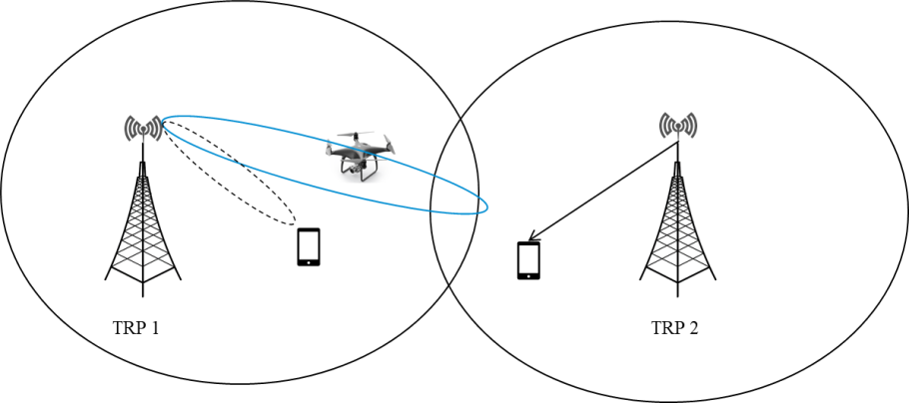  Figure 4.3.1-4 DL sensing RS transmissions in the adjacent cells interfere with UE’s communication signal/channel(s) reception  As shown in Figure 2.6-5, with the decrease of BS electronic down tilt angle (for low altitude airspace), the interference to UEs in neighboring BS increases and the receiver RSRP of received signal increase. Near 10dB difference can be observed by comparing BS electronic down tilt angle 12 degree and BS electronic down tilt angle 0 degree. In the simulation, the beamforming 3dB-width is assumed as 30°.  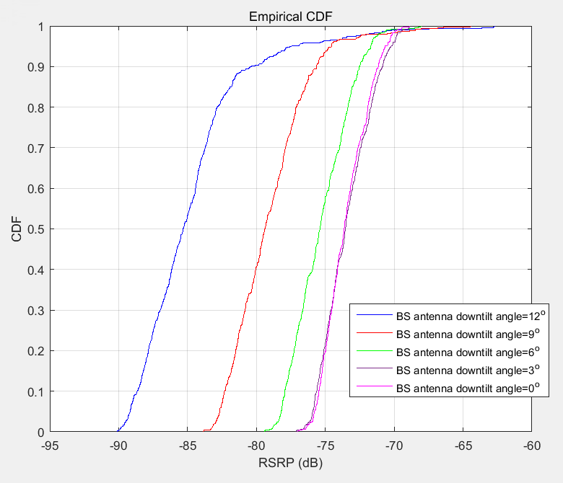  Figure 4.3.1-5: Interference level (represented in RSRP) with different BS antenna electronic down tilt angle

In summary, both self-interference and cross-interference exist in ISAC system. On top of that, the interference between communication and sensing should also be considered. The interference mitigation solutions should be considered to ensure performance and reliability for both sensing and communication.
Proposal 16: Study the interference handling for ISAC considering the following:
- Self-interference
- Cross-interference
- Interference between sensing nodes
- Interference between sensing and communication, especially for UAV scenario

Interference mitigation solutions
In the following paragraph we will discuss potential interference mitigation solutions for self-interference and cross-interference respectively.
- BS Self-interference
To enable mono-static sensing, it is necessary to study how to effectively suppress the signals transmitted by itself. The following can be studied:
  - Reference signal design: for an example, LFM is more robust to interference and noise for its spread spectrum nature. For another example, the transmission and the reception of sensing RS can be in TDMed manner as aforementioned in section 2.4.
  - Physical isolation: an antenna isolation fence can be inserted between two antennas to improve the isolation between the transmitting and receiving antennas, enhances the antenna's radiation performance and increases the antenna gain.

- BS-BS interference, i.e. cross-interference
For the study of cross-interference mitigation, both interference between sensing and communication and interference between sensing nodes should be considered. A variety of approaches including coordinated resource allocation, spatial domain mitigation and power domain mitigation can be used for interference mitigation. Figure 2.6.2-2 shows an example of procedures for ISAC interference mitigation
  - Coordinated resource allocation: the muting pattern could be applied per sensing RS resource.
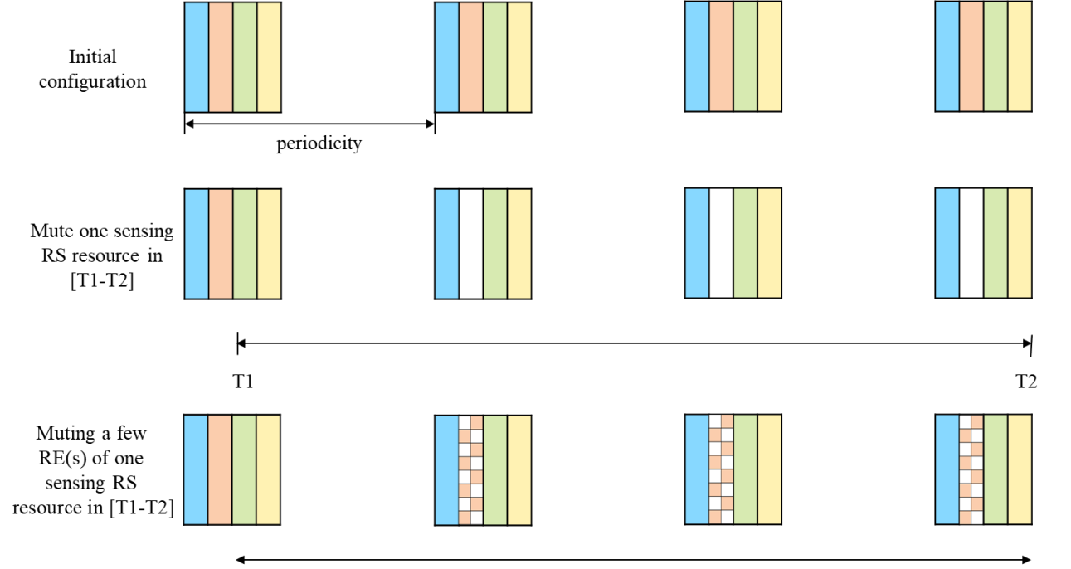
Figure 5.3.2-1 Muting patterns for interference mitigation
  - Spatial domain interference mitigation: the direction of Tx beam can be adjusted to improve the received performance of the desired signal or the direction of Rx beam can be adjusted to be orthogonal to the direction of interference signal.
  - Power control interference mitigation: increase the desired signal power or reduce the interference power.
  - Multiplexing sensing and communication: as mentioned in 3.1.5.1, the current 5G-A deployment shows a severe interference from the communication BS to the sensing BS, and the communication BS cannot be used when sensing BS is sensing. For such a severe interference, multiplexing can be used to cancel the interference.

- BS-UE interference, especially from sensing to communication
For communication from BS to UE in NR, CSI-RS or CSI-IM can be configured from the serving gNB to the UE for interference measurement. In details, three CSI-RS configurations can be associated to one CSI report configuration, where the first CSI-RS configuration is for channel measurement, and the other two are for interference measurement.
For ISAC system, compared with NR, new interference is caused between sensing RS and communication signals. In such case, it is better to further inform UE the sensing RS configuration for CSI measurement, e.g. for interference measurement, even such noticed UE do not involve the sensing measurement operation.
As shown in the following figure, a unified CSI framework for UE can be studied for all kinds of physical layer CSI measurement report including cross-link interference measurement, interference from sensing to communication, the traditional CSI measurement, etc. Based on this, if the RS for channel measurement is not configured, sensing RS may be only used for interference measurement, and then only RSRP may be reported.

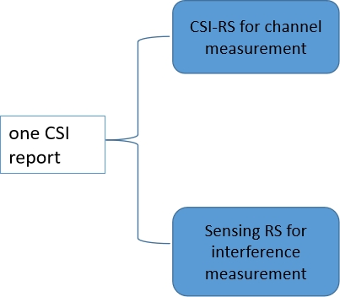
Figure 5.3.2-2 CSI report based on sensing RS for interference measurement
Based on the above analysis, we have the following proposal:
Proposal 17: Study possible solutions for interference mitigation in ISAC:
- Spatial domain interference mitigation
- Power control interference mitigation
- Coordinated resource allocation
- Multiplexing sensing and communication
- CSI/Interference measurement based on sensing RS
- Inform sensing RS configuration to UE for interference cancellation, even when such UE has no sensing service currently.

Sensing measurement calibration
It is because that sensing target could be any passive object, which is not registered in network, so it would be hard for 6G system to obtain some prior information about the sensing target before detection. Therefore, the accuracy of sensing measurement can not be checked by 6G system if no extra enhancement is applied, and the final sensing result won’t be reliable for any further usage. From ZTE’s perspective, accuracy of sensing measurement could be ensured by following different methods:
- Sensing reference unit (SRU). SRU could be some sensing device with capability to operate high accurate sensing measurement on around environmental objects. Such SRU should be registered in network for its sensing accuracy and capability to share its sensing measurement data. The ideal sensing measurements generated by SRU, as well as some other assistance information including position and orientation of SRU, could be shared with other UE, aNB or SF. Then sensing device around the SRU could compare the it’s measurement with the shared sensing measurement from SRU locally, to modify its sensing parameters dynamically. 6G network could also check sensing accuracy of sensing device around the SRU by comparing its sensing measurement on same environmental objects.
Figure 6-1 Sensing reference unit (SRU)
- Sensing reference path (SRP). Doppler measurement could call for continuous measurement across multiple OFDM symbols from multiple slot. During such long time measurement, no matter sensing Tx device or sensing Rx device may change the DL/UL working status for other communication usage. As long as the radio link changes it DL/UL working status, an random phase step change would happen on the carrier frequency. If mono-static sensing mode is used, regular Tx and Rx on the sensing device would share same carrier frequency oscillator. Then one phase step change would be added during modulation, and one same phase step change would be counteracted during demodulation. Therefore mono-static sensing mode could keep the phase continuity naturally without any enhanced design. However, for bi-static sensing, it is because that different carrier frequency oscillators are used on Tx and Rx, so it would be necessary to track the unknown phase step change happens on sensing Tx/Rx and mitigate its effect. SRP could be used to track the phase step changes. SRP could be one stable multipath component, which is usually LOS path. If sensing Tx and Rx does not move so much, the phase measurement on such SRP should be supposed to keep unchanged. Then if any phase step change happens on Tx or Rx, it could be reflected on the phase changes on SRP. By such way, the phase step change could be estimated.
Figure 6-2 Sensing reference path (SRP)
- Sensing reference object (SRO). SRO could be some sensing target with some known characteristics, e.g. detailed position, orientation, speed and RCS. The detailed known information should be registered in 6G network, and also could be shared with sensing device. Received some sensing measurement data on certain SRO from some sensing device, 6G network could use the prior information of SRO to check the accuracy of sensing measurement, and then given the modified configuration to improve the sensing accuracy. Such prior information could be also shared with sensing device, to allow sensing device optimize local sensing configurations. For example, if prior information that SRO keeps static could be shared with sensing device, it could also measure the phase step change on Tx/Rx by sensing measurement on SRO, and phase continuity for Doppler measurement could also be ensured.
Figure 6-3 Sensing reference object (SRO)
Proposal 18: RAN1 should study method to guarantee the accuracy of sensing measurement. Sensing reference unit (SRU), Sensing reference object (SRO), and sensing reference path (SRP) should be studied to optimize sensing performance.
- Sensing reference unit (SRU) could be some sensing device with capability to operate high accurate sensing measurement on around environmental objects.
- Sensing reference object (SRO) could be some sensing target with some known characteristics, e.g. detailed position, orientation, speed and RCS.
- Sensing reference path (SRP) could be some multipath with some known characterstics, e.g., LOS path.

UE location awareness
In the sensing modes in the case when base station and UE participate, as shown in Figure 7-1, the location of the UE is extremely important for determining the position of the sensing target.
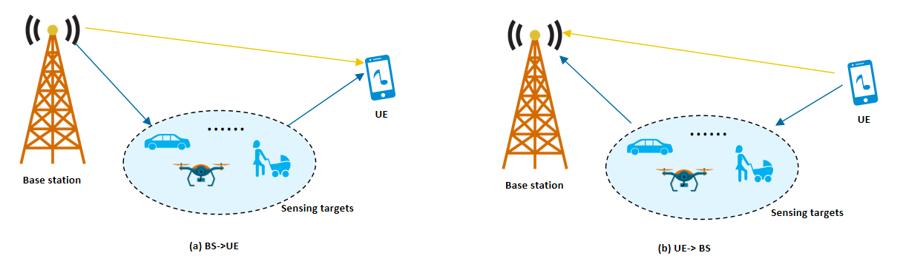
Figure 7-1 Sensing between BS and UE
Such UE location information is important for both sensing and sensing assisted communication usage.
Sensing with UE location:
In a TRP–UE bistatic geometry, the target lies on a prolate ellipsoid whose two foci are the transmitter and the receiver, and whose major axis is set by the measured bistatic range sum . Once is known, the inverse mapping to is a purely geometric operation that requires both foci to be known. The base station knows , but the UE — the second focus — is unlocalized by default, and this single missing vector breaks the geometric closure of the problem. Then the ellipsoid cannot be anchored in space.
Extra UE measurement report to aNB does not rescue the geometry. A UE-side AoA is expressed in the UE's local antenna frame; converting it into a global ray requires both the ray's origin (UE position) and orientation (UE attitude). Without , the AoA defines only an unanchored local direction and cannot be combined with delay-domain measurements.
Using multiple TRP paired with same UE maybe one potential solution, because more measurements could be obtained while unknown parameters keep unchanged. More than one set of equation may be used to calculate position of sensing target and UE simultaneously. However, such method would require to map different paths measured by different TRP together with one same sensing target to be detected. Such mapping operation would be affected by SINR a lot and related accuracy would be worse.
Sensing assists communication with UE location:
Sensing outputs target positions in the global frame, whereas communication needs beam directions, path delays, AoDs, and Dopplers relative to a specific UE. The bridge between the two is the mapping link in which UE location is an indispensable geometric anchor. Without it, sensing results remain an unattributed point cloud floating in world coordinates, with no way to be projected onto any particular TRP–UE link.
- Beam prediction and tracking: With both UE location and sensing information, aNB would be able to decide the optimum beam direction considering both LOS link and reflection link.
- Sensing-based channel prediction: For channel prediction of MIMO usage, all sensing information aggregated in aNB could be helpful as long as UE’s location could be known by aNB. CIR between aNB and UE could be represented by . Sensing measurement could already provide or generate the necessary information related to and , and aNB could predict the channel information based on UE location and then determine the precoding vector to be used.
- Blockage prediction: Blockage prediction must test whether a sensed obstacle lies inside the Fresnel zone of the TRP–UE line, which cannot even be drawn without UE location.
- Predictive handover: Predictive handover propagates the UE trajectory, requiring the current position as the initial condition.
Eventually, the sensing assisting communication loop is Sensing → Geometry Fusion → Link Adaptation, with UE location as the reference anchor of that projection. If this anchor is missing, the loop is broken in the middle: no matter how accurate the sensed target is, it cannot be translated into actionable beam, channel, or scheduling decisions for a given UE.

Observation 7: UE location and orientation is essential for both sensing and sensing assisting communication:
- For TRP-UE bi-static or UE-TRP bi-static sensing mode, only with UE sensing measurement report, 6G network is unable to decide locations of sensing targets in GCS, because UE location and orientation are unknown and changing, especially when UE is moving.
- For sensing assisting communication, UE location and orientation is key to translate sensing information to channel information, e.g. beam, CIR, LOS condition, etc.
Proposal 19: 6G network are proposed to be able to request UE sensing measurement report as well as location and orientation for sensing and sensing assisting communication while protecting UE’s privacy.

Conclusion
In conclusion, we have following proposals and observations for RAN1#125:
Proposal 1: From RAN1 perspective, study the procedure/signaling among aNB, UE, and SF.
Proposal 2: Study the following sensing modes without sidelink involvement for 6G ISAC.
- Mono-static: TRP mono-static, UE mono-static
- Multi-static: Simultaneous TRP mono-static and TRP-UE bi-static
- Bi-static: TRP bi-static, UE-TRP bi-static, TRP-UE bi-static, UE bi-static
Proposal 3: From RAN 1 perspective, to support of BS mono-static, UE mono-static (without PC5 interface), BS bi-static, BS->UE, UE->BS sensing modes, at least the following procedures can be the starting points
- Between BS and SF
  - aNB information transmitted from aNB to SF
  - Measurement request from SF to aNB
  - Measurement report from aNB to SF
- Between aNB and UE
  - UE capability from UE to aNB
  - RS configuration or assistance information from aNB to UE
  - Measurement request from aNB to UE
  - Measurement report from UE to aNB
    - Including sensing assists communication.
- RS configured by SF and sensing report from UE to SF are not supported considering latency and flexibility.
Proposal 4: From RAN1 perspective, the following can be studied as sensing measurement request from aNB to UE:
- Sensing mode
- Configurations of reference signal
- Requested measurement report metrics
- Sensing assistance data including
  - Sensing area such as Delay range, Doppler range, Angle range to be measured.
  - Characteristic of sensing targets
  - Any environmental clutter to be omitted.
Proposal 5: From RAN1 perspective, the following can be studied as sensing measurement request from SF to aNB:
- Sensing mode
- Requested measurement report metrics
- Sensing assistance data including
  - Sensing area such as Delay range, Doppler range, Angle range to be measured.
  - Characteristic of sensing targets
  - Any environmental clutter to be omitted.
Proposal 6: RAN1 should confirm at least parts of levels and options. Level D should be confirmed first, with confidence metric and power metric confirmed as following:
- Power metric: RSRPP.
- Confidence metric: Uncertainty range and related confidence value (if needed) for each reported quantity.
Proposal 7: RAN1 shall support UE to report sensing measurement to aNB.
- Layer 1 signaling similar as CSI measurement report could be a startomg point for UE location, delay/range, 3D angle, and Doppler report.
Observation 1: Measurement of sensing modes of TRP-UE bi-static, UE-bi-static, and TRP mono-static could be beneficial for beam management:
- Sensing measurement would include rich information on paths of environment. Beam selection could be finished accurately with fewer sensing RS resource to save the overhead for beam sweeping for high frequency.
- For TRP mono-static sensing, aNB could obatin the characteristic of environment, and schedule optimistic beam before UE’s measurement report if knowing with UE’s location. Stable beam selection and connection could be ensured especially for high speed UE when link failure happens frequently.
- Pulse signal can be used for communication beam selection with an accurate ration ≥ 94%.
Observation 2: Sensing measurement report from UE could be reused for CSI measurement usage with following benefits:
- Resource reusing: Sensing RS could be resued for communication assistance without invloving more overhead.
- Better accuracy: Sensing measurement report has better resolution and accuracy on delay/Doppler/angle measurement. aNB could make better precoding with such comprehensive information.
Proposal 8: Study signaling and network structure for sensing assisted communication considering following use cases:
- Sensing assists beam management
- Sensing assists CSI measurement
To support sensing assisted communication, RAN1 should support that:
- UE reports sensing measurement directly to aNB
- aNB obtains UE’ s location information for communication assistance while protecting the UE's privacy
Observation 3: The latency for aNB to access UE’s sensing measurement report is estimated at least as following:
- Option1A (UE measurement directly sent to aNB):
- Option1B (UE measurement sent to SF, and then from SF to aNB):
Latency of Option1B would be much longer than normal L1 measurement report for beam management and CSI measurement feedback. For sensing assisting communication, aNB does not expect to receive sensing measurement report of UE with more latency compared with normal communication procedure. Huge latency would make UE measurement report from SF helpless for communication assistance.
Proposal 9: For sensing assisted communication, UE directly reports sensing measurement data to aNB.
Observation 4: Both CSI-RS and TRS don’t support sufficient frequency domain density and time domain density for tracking on high speed target without ambiguity.
- Comb size 4 for CSI-RS or TRS
- Period of CSI-RS: 4, 5, 8, 10, 16, 20, 32, 40, 64, 80, 160, 320, and 640 slots
- Period of TRS: 10, 20,40, 80, 160, 320, and 640 slots
  - In each period, at most four periodic TRS in two consecutive slots with two periodic TRS resources in each slot could be configured.
Proposal 10: Considering at least the following aspects for enhancements on CSI-RS or TRS:
- Comb size reduction, e.g., comb-2 in frequency domain.
- Time density reduction on communication RS is not supported because of high and unacceptable overhead.
Observation 5: Assuming the sensing RS is repeated transmission with a large period of with totalperiods. During each period, the non-uniform sensing RS is transmitted at time point, referred to the starting point of each period. Following metrics should be considered for non-uniform RS design:
Unambiguous Doppler range |  | The maximum Doppler frequency span that can be measured without aliasing. For non-uniform RS, it is determined by the GCD of all sampling intervals, and can far exceed the uniform-sampling limit .
Doppler resolution |  | The minimum distinguishable frequency separation between two Doppler components.
Peak sidelobe level ratio (PSLR) |  | The PSLR is ratio (in dB) of the highest sidelobe to the main peak of the ambiguity function. A lower PSLR means better suppression of spurious peaks and more reliable target detection.
Proposal 11: Study joint sensing RS set with at least following two methods:
- Joint sensing RS set with multiple types of RS, e.g. using CSI-RS, Pulse RS, and PTRS together for sensing measurement.
- Joint sensing RS set with multiple RS resources of one type of RS, e.g., CSI-RS resources with different time offset for time domain sparse pattern.
Observation 6: For sensing mode of UE->BS, the motivation is to control the UE transmission power so that the receiving power of the path UE-ST-BS meets the need.
- For the paths not related to UE-ST-BS, e.g. LOS link between UE and BS is useless information
Proposal 12: Study new power control mechanism for UL sensing signal, such as RSRPP based pathloss computation, etc.
Proposal 13: Determine the DL transmission power for sensing dedicated RS independently of communication.
Proposal 14: RAN1 should study the configurations of coherent processing interval (CPI) for UE, e.g. how to ensure coherence of TA, power, etc. during one CPI for sensing measurement.
Proposal 15: For beam management, RAN1 should study whether and how to enhance beam configuration for multiple sensing targets scenarios, e.g., directly configure 3D angles of beam directions mapped with one sensing RS.
Proposal 16: Study the interference handling for ISAC considering the following:
- Self-interference
- Cross-interference
- Interference between sensing nodes
- Interference between sensing and communication, especially for UAV scenario
Proposal 17: Study possible solutions for interference mitigation in ISAC:
- Spatial domain interference mitigation
- Power control interference mitigation
- Coordinated resource allocation
- Multiplexing sensing and communication
- CSI/Interference measurement based on sensing RS
- Inform sensing RS configuration to UE for interference cancellation, even when such UE has no sensing service currently.
Proposal 18: RAN1 should study method to guarantee the accuracy of sensing measurement. Sensing reference unit (SRU), Sensing reference object (SRO), and sensing reference path (SRP) should be studied to optimize sensing performance.
- Sensing reference unit (SRU) could be some sensing device with capability to operate high accurate sensing measurement on around environmental objects.
- Sensing reference object (SRO) could be some sensing target with some known characteristics, e.g. detailed position, orientation, speed and RCS.
- Sensing reference path (SRP) could be some multipath with some known characterstics, e.g., LOS path.
Observation 7: UE location and orientation is essential for both sensing and sensing assisting communication:
- For TRP-UE bi-static or UE-TRP bi-static sensing mode, only with UE sensing measurement report, 6G network is unable to decide locations of sensing targets in GCS, because UE location and orientation are unknown and changing, especially when UE is moving.
- For sensing assisting communication, UE location and orientation is key to translate sensing information to channel information, e.g. beam, CIR, LOS condition, etc.
Proposal 19: 6G network are proposed to be able to request UE sensing measurement report as well as location and orientation for sensing and sensing assisting communication while protecting UE’s privacy.

References
- RP-251881, New SID: Study on 6G Radio, NTT DOCOMO (Moderator)
- Sim, Min Soo, et al. "Deep learning-based mmWave beam selection for 5G NR/6G with sub-6 GHz channel information: Algorithms and prototype validation." IEEE Access 8 (2020): 51634-51646.

